**VIRTUAL LABORATORY**

**FOR**

**COMMUNICATION SYSTEMS**

**A PROJECT REPORT**

*Submitted by*

|  |  |
| --- | --- |
| **ROJIN RAJU** | **311018106045** |
| **SRI SAKTICHARAN** | **311018106054** |
| **UMESH HARIHARA SUDAN** | **311018106066** |

*In partial fulfilment of the award of the*

*Degree of*

**BACHOLER OF ENGINEERING**

**IN**

**ELECTRONICS AND COMMUNICATION ENGINEERING**

**KCG COLLEGE OF TECHNOLOGY,**

**KARRAPAKAM, CHENNAI-97**

**ANNA UNIVERSITY: CHENNAI 600 025**

*April 2022*

**ANNA UNIVERSITY: CHENNAI 600 025**

**BONAFIDE CERTIFICATE**

Certified that this project report “**VIRTUAL LABORATORY FOR COMMUNICATION SYSTEMS**” is the bonafide work of ROJIN RAJU (311018106045), SRI SAKTICHARAN (311018106054) and UMESH HARIHARA SUDAN M. (311018106066) who carried out the project report work under my supervision.

|  |  |
| --- | --- |
| **SIGNATURE** | **SIGNATURE** |
| Dr KAVITHA BALAMURUGAN | Ms THYLA |
| **HEAD OF THE DEPARTMENT** | **SUPERVISOR** |
| Professor and Head | Assistant Professor |
| Department of Electronics and communication Engineering | Department of Electronics and communication Engineering |
| KCG College of Technology | KCG College of Technology |
| Karapakkam, Chennai -600097 | Karapakkam, Chennai -600097 |

Submitted for the Viva voice examination held at KCG College of technology

On __________________ .

|  |  |
| --- | --- |
| **INTERNAL SIGNATURE** | **EXTERNAL SIGNATURE** |

**ACKNOWLEDGEMENT**

First and foremost, we proudly thank the almighty for showering blessings for the successful completion of this project. We deeply express thanks and respect to our beloved parents for their invaluable love, moral support and constant encouragement in every walk of our life.

We wish to express my deep sense of gratitude to **Dr P. DEIVA SUNDARI**, Principal, KCG College of Technology, Chennai, for having given expert guidance, kind and cooperative encouragement, inspiring and keen interest shown throughout the course of this project.

We whole heartedly thank **Dr Kavita Balamurugan**, Head of the Department, Department of Civil Engineering, KCG College of Technology, for having provided the necessary infrastructural facilities and constant encouragement given during the entire course of study.

We proudly acknowledge our deepest sense of gratitude to our guide **Ms. Thyla B**, Assistant Professor, Department of Electronics and communication Engineering, for her enthusiastic inspiration, unstinted guidance and scholarly advice imparted throughout the course of this project.

**ABSTRACT**

Physical distances and the lack of resources make us unable to perform experiments especially when they involve sophisticated instruments. Web based and video-based courses address the issue of teaching to some extent. Conducting joint experiments by two participating institutions and also sharing costly resources has always been a challenge. With the present internet and computer technologies the above limitations can no more hamper students and researchers in enhancing their skills and knowledge. In a country such as ours, costly instruments and equipment need to be shared with fellow researchers to the extent possible. Virtual labs aim to provide remote – access to laboratories in various disciplines of science and engineering for students at all levels from undergraduate to research. It also intends to develop a complete learning management system where the students can avail the various tools for learning, including additional web resources, video lectures, animated demonstrations and self-evaluation. Virtual labs help the students to practice and learn science and engineering and the experiments behind them. Virtual labs is a project initiated by the Ministry of Human Resource Development, Government of India under the national mission on education through Information and communication technology. Virtual laboratories are popping up in school districts and online learning curriculum across the country and making it easier and less expensive for students to do experiments remotely.

The virtual laboratory is an interactive environment for creating and conducting simulated experiments, a playground for experimentation.

**TABLE OF CONTENTS**

|  |  |
| --- | --- |
| **SL NO.** | **TITLE** |
|  | **Acknowledgement** |
|  | **Abstract** |
| **1** | **Introduction** |
|  | Objective |
|  | List of experiments |
|  | Frequency modulation |
|  | Frequency shift keying |
|  | Amplitude Shift keying |
|  | Pulse Code Modulation |
|  | Amplitude modulation |
| **2** | **Literature survey** |
|  | General |
|  | Review of literature |
| **3** | **Methodology** |
|  | General |
|  | Frequency Modulation |
|  | Amplitude Shift Keying |
|  | Frequency Shift Keying |
|  | Pulse code modulation |
|  | Amplitude modulation |
| **4** | **System Architecture** |
|  | General |
|  | Technology Stack |
|  | Structure of the program |
|  | Formulae Used |
| **5**  **6** | **Conclusion**  **Result** |
|  |  |

**CHAPTER 1**

**INTRODUCTION**

**1.1 OBJECTIVE**

To provide remote-access to labs in various disciplines of science and engineering. To enthuse students to conduct experiments by arousing their curiosity. To share costly equipment and resources, which are otherwise available to limited number of users due to constrains on time and geographical. To provide a complete learning management system around the virtual labs where students can avail the various tools for learning, including additional web resources, video lectures, animated demonstrations and self-evaluation.

Schools and students that use virtual lab have access to cutting- edge technology when it comes to experimentation. Companies that build and maintain virtual labs must compete with each other to stay ahead of technology progression and that raises the quality of options for students. With a virtual lab, students do not have to settle on outdated, yet expensive equipment because a school cannot afford to replace it consistently.

Virtual lab is important for educators particularly science educators to understand how to use virtual labs effectively in classrooms. With budget challenges virtual labs provide an avenue for teachers to be able to present demonstrations and conduct labs that they might not have been able to afford. Additionally, they can help present abstract ideas that may be hard to visualize or explain.

**1.2 EXPERIMENT LIST**

The following Experiments are executed using the virtual lab software for the betterment of output values rather than the physical output values,

1. Frequency Modulation (FM)

2. Frequency Shift Keying (FSK)

3. Amplitude Shift Keying (ASK)

4.Pulse Code Modulation(PCM)

5.Amplitude Modulation(AM)

**1.3 FREQUENCY MODULATION**

Frequency modulation (FM) is a type of modulation where the frequency of the carrier is varied in accordance with the modulating signal. The amplitude of the carrier remains constant. The information bearing signal (the modulating signal) changes the instantaneous frequency of the carrier. Since the amplitude is kept constant, FM modulation is a low noise process and provides a high quality modulation technique which is used for music and speech in hi-fidelity broadcasts. The amplitude of the carrier depends on m. the modulation index.

The classic definition of FM is that the instantaneous output frequency of a transmitter is varied in accordance with the modulating signal. Recall that we can write an equation for a sine wave as follows: e(t) = Ep sin(ωt + φ)While amplitude modulation is achieved by varying Ep, frequency modulation is realized by varying ω in accordance with the modulating signal or message. Notice that one can also vary φ to obtain another form of angle modulation known as phase modulation (PM).

**FM analysis**

FM applications are divided into two broad categories:

**Wideband FM (WFM)**

**Narrowband FM (NBFM)**

The primary difference between the two types of FM is the number of sidebands in the modulated signal. Wideband FM has a large number (theoretically infinite) number of sidebands. Narrowband FM has only a single pair of significant sidebands.

It is possible to determine if a particular FM signal will be wide or narrow band by looking at a quantity called the Deviation Ratio (DR). It is defined as the ratio of the maximum deviation of the FM signal to the maximum modulating frequency:

**DR= δ/fmax**

The DR is also the modulation index of the highest modulating frequency. If the DR ≥ 1.0 it is called wideband FM (WFM) and DR< 1.0 the modulation

The figure below compares the spectra of a WFM signal (DR = 5) and a NBFM signal (DR = 0.5). The separation between sidebands is equal to the modulating frequency. Thus the bandwidth for NBFM is 2*fm , which is the same as for AM. However, for WFM, the bandwidth is approximately 2N* fm , where N = the number of sidebands.

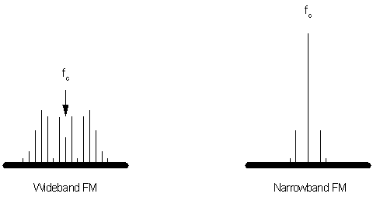

**1.4 FREQUENCY SHIFT KEYING**

FSK is the digital modulation technique in which the frequency of the carrier signal varies according to the digital signal changes. FSK is a scheme of frequency modulation. The output of a FSK modulated wave is high in frequency for a binary High input and is low in frequency for a binary Low input. The binary **1s** and **0s** are called Mark and Space frequencies.

The following image is the diagrammatic representation of FSK modulated waveform along with its input.

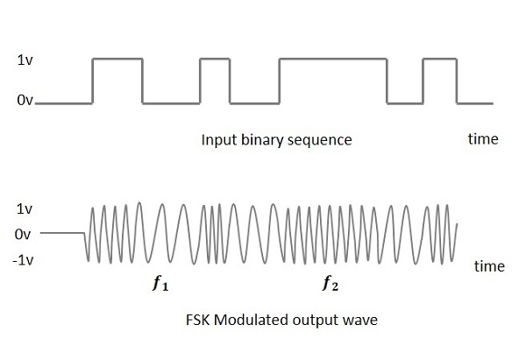

**FSK Modulator**

The FSK modulator block diagram comprises of two oscillators with a clock and the input binary sequence. Following is its block diagram.

The two oscillators, producing a higher and a lower frequency signal, are connected to a switch along with an internal clock. To avoid the abrupt phase discontinuities of the output waveform during the transmission of the message, a clock is applied to both the oscillators, internally. The binary input sequence is applied to the transmitter so as to choose the frequencies according to the binary input

. 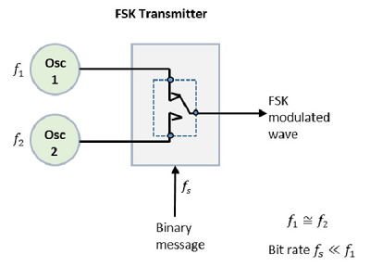

## FSK Demodulator

There are different methods for demodulating a FSK wave. The main methods of FSK detection are **asynchronous detector** and **synchronous detector**. The synchronous detector is a coherent one, while asynchronous detector is a non-coherent one.

### **Asynchronous FSK Detector**

The block diagram of Asynchronous FSK detector consists of two band pass filters, two envelope detectors, and a decision circuit. Following is the diagrammatic representation.

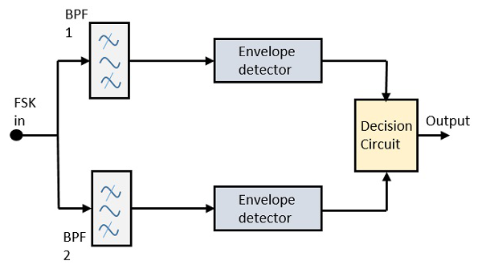

The FSK signal is passed through the two Band Pass Filters BPFs, tuned to **Space** and **Mark** frequencies. The output from these two BPFs look like ASK signal, which is given to the envelope detector. The signal in each envelope detector is modulated asynchronously. The decision circuit chooses which output is more likely and selects it from any one of the envelope detectors. It also re-shapes the waveform to a rectangular one.

### **Synchronous FSK Detector**

The block diagram of Synchronous FSK detector consists of two mixers with local oscillator circuits, two band pass filters and a decision circuit. Following is the diagrammatic representation.

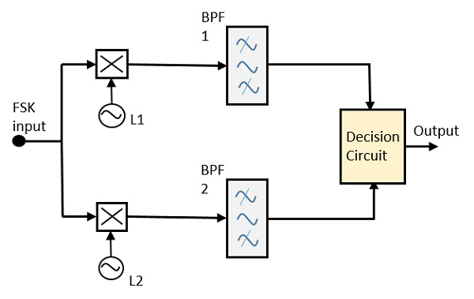

The FSK signal input is given to the two mixers with local oscillator circuits. These two are connected to two band pass filters. These combinations act as demodulators and the decision circuit chooses which output is more likely and selects it from any one of the detectors. The two signals have a minimum frequency separation.

For both of the demodulators, the bandwidth of each of them depends on their bit rate. This synchronous demodulator is a bit complex than asynchronous type demodulators.

**1.5. AMPLITUDE SHIFT KEYING**

Amplitude Shift Keying (ASK) is a type of Amplitude Modulation which represents the binary data in the form of variations in the amplitude of a signal.

Any modulated signal has a high frequency carrier. The binary signal when ASK modulated, gives a zero value for Low input while it gives the carrier output for High input.

The following figure represents ASK modulated waveform along with its input.

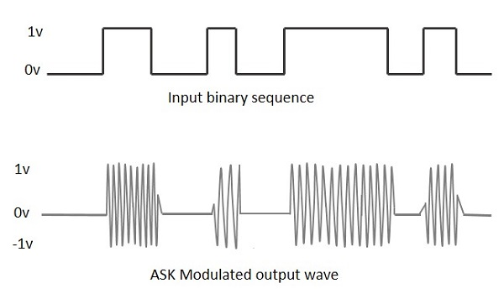

**ASK Modulator**

The ASK modulator block diagram comprises of the carrier signal generator, the binary sequence from the message signal and the band-limited filter. Following is the block diagram of the ASK Modulator.

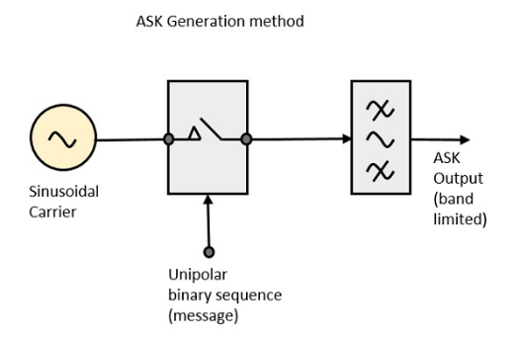

The carrier generator, sends a continuous high-frequency carrier. The binary sequence from the message signal makes the unipolar input to be either High or Low. The high signal closes the switch, allowing a carrier wave. Hence, the output will be the carrier signal at high input. When there is low input, the switch opens, allowing no voltage to appear. Hence, the output will be low.

## ASK Demodulator

There are two types of ASK Demodulation techniques. They are −

* **Asynchronous ASK Demodulation/detection**
* **Synchronous ASK Demodulation/detection**

The clock frequency at the transmitter when matches with the clock frequency at the receiver, it is known as a **Synchronous method**, as the frequency gets synchronized. Otherwise, it is known as **Asynchronous**.

## Asynchronous ASK Demodulator

The Asynchronous ASK detector consists of a half-wave rectifier, a low pass filter, and a comparator. Following is the block diagram for the same.

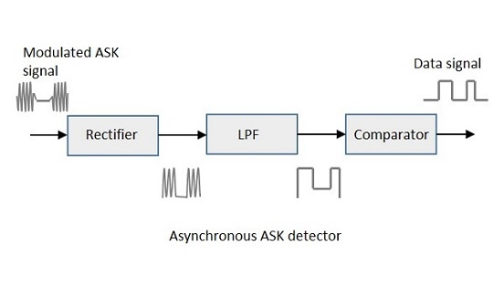

The modulated ASK signal is given to the half-wave rectifier, which delivers a positive half output. The low pass filter suppresses the higher frequencies and gives an envelope detected output from which the comparator delivers a digital output.

## Synchronous ASK Demodulator

Synchronous ASK detector consists of a square law detector, low pass filter, a comparator, and a voltage limiter. Following is the block diagram for the same.

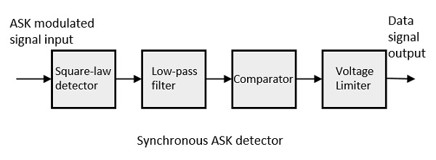

The ASK modulated input signal is given to the square law detector. A square law detector is one whose output voltage is proportional to the square of the amplitude modulated input voltage. The low pass filter minimizes the higher frequencies. The comparator and the voltage limiter help to get a clean digital output.

**1.6. PULSE CODE MODULATION**

Pulse-code modulation (PCM) is a method used to digitally represent sampled analog signals. It is the standard form of digital audio in computers, compact discs, digital telephony and other digital audio applications. In a PCM stream, the amplitude of the analog signal is sampled regularly at uniform intervals, and each sample is quantized to the nearest value within a range of digital steps.

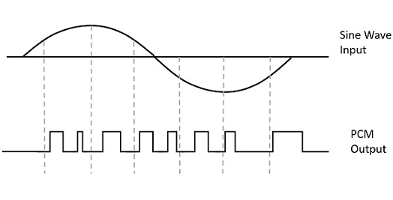

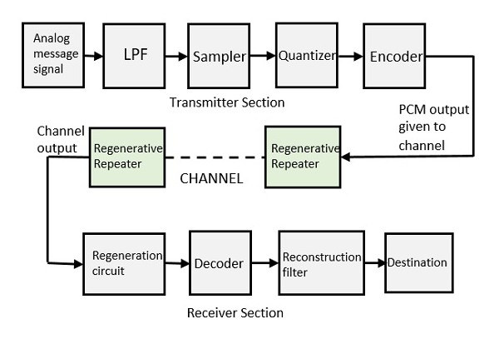

**PCM transmitter**

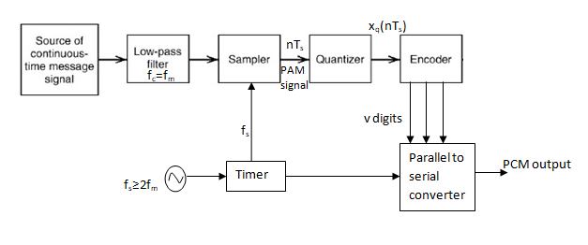

In PCM transmitter , the signal x(t) is first passed through the low-pass filter of cut-off frequency fm Hz . This low-pass filter blocks all the frequency components above fm Hz .This means that now the signal x(t) is bandlimited to fm Hz . The sample and hold circuit then samples this signal at the rate of fs. Sampling frequency fs is selected sufficiently above nyquist rate to avoid aliasing i.e., fs ≥ 2fm The output sample and hold circuit is denoted by x(nTs). This signal x(nTs) is discrete in time and continuous in amplitude.

**PCM Transmission Path**

The path between the PCM transmitter and receiver over which the PCM signal travel, is known as PCM transmission path.

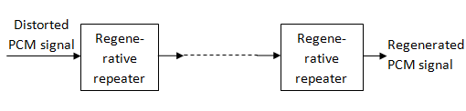

**PCM Receiver**

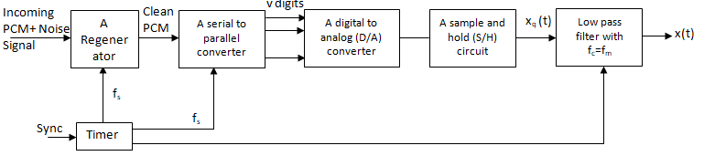

**ANALOG TO DIGITAL**

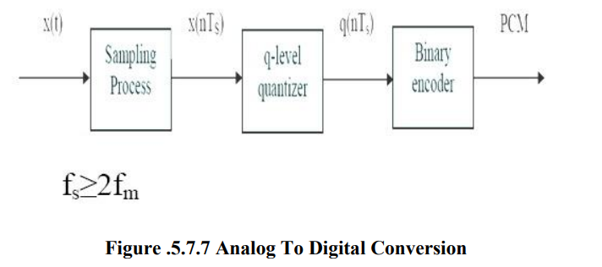

The output of the sampler x(nTs) which is discrete in time is fed to a „q‟ level quantizer. The quantizer compares the input x(nTs) with it's fixed levels. It assigns any one of the digital level to x(nTs) that results in minimum distortion or error. The error is called quantization error, thus the output of the quantizer is a digital level called q(nTs). The quantized Figure .5.7.7 Analog To Digital Conversion Diagram Source Brain Kart signal level q(nTs) is binary encode. The encoder converts the input signal to v digits binary word.The receiver starts by reshaping the received pulses, removes the noise and then converts the binary bits to analog shown in the figure 5.7.8. The received samples are then filtered by a low pass filter; the cut off frequency is at fc.

**fc=fm**

**DIGITAL TO ANALOG**

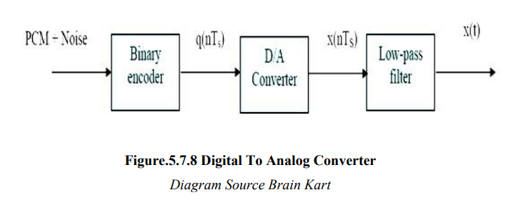

**1.7.AMPLITUDE MODULATION**

In amplitude modulation (AM), the message signal is impressed on the amplitude of the carrier signal. This results in a signal whose amplitude is a function of the message signal.

Forms of AM: AM signals may be of various types such as

1. Conventional double sideband AM (DSB-AM)

2. Double sideband suppressed carrier AM (DSBSC-AM)

3. Single sideband suppressed carrier AM (SSBSC-AM)

4.Vestigial sideband AM (VSBSC-AM)

These different types of amplitude modulation schemes are used for different applications. For example, conventional double sideband AM is used in radio broadcast, single sideband suppressed carrier AM is used in analog telephony and vestigial sideband AM is used in TV broadcast.



**Representation of DSB-AM signal:**

Mathematically, a DSB-AM wave can be represented as follows:

Let the carrier signal is denoted by c(t)=Acsin(2πfct) , and the modulating signal is denoted by m(t).

The modulated signal Cm(t)  can be written as Cm(t)=Ac(1+m(t))sin(2πfct).

**Spectrum of modulated signal:**

If M(f) represents the Fourier transform of the modulating signa m(t) ,then the spectrum of the amplitude modulated signal Cm(t) can be written as

Cm(f)=Ac/2j[δ(f-fc)-δ(f+fc)]+Ac/2j[M(f-fc)-M(f+fc)]

**Single tone modulation:**

Let us consider a special case when the modulating signal m(t) is given by m(t)=Amsin(2πfmt) and *fm<c*

The modulated waveform can be represented as:

Cm(t)=(Ac+Amsin(2πfmt))sin(2πfct)=Ac(1+msin(2πfmt))sin(2πfct)

Here,m is the index of modulation and m≤l is usually used.

The modulated waveform for typical values m=0.5, Ac=2v,fm=1Khz and fm=10Khz is shown in the figure1 below.

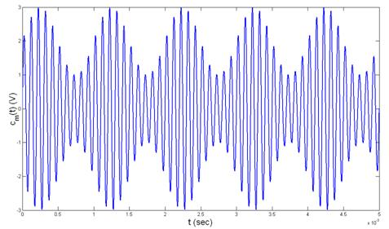

Figure-1: Amplitude modulated wave

If m>1, the signal is over modulated and for such cases the demodulated waveform will be distorted. Figure 2 shows an over-modulated AM wave.

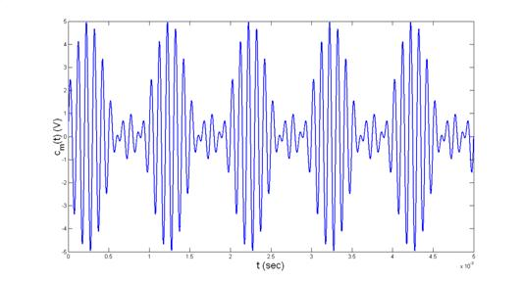

Fig.2 Over-modulated wave

Cm(t) can be written as

Cm(t)=Acsin(2πfct)+Acmsin(2πfmt)sin(2πfct)

= Acsin(2πfct)+Acm/2 cos (2π(fc- fm)t)-Acm/2 cos(2π(fc+fm)t)

Thus we find that for a single tone AM, the modulated signal has three frequency components, namely, fc,(fc+fm) and (fc- fm).

Since Cm(t)=(Ac+Amsin(2πfmt))sin(2πfct)=Ac(1+msin(2πfmt))sin(2πfct), the envelope of the carrier has the wave shape of the modulating signal.

For the Figure 3, Amax=Ac(1+m) and Amin=Ac(1-m) respectively

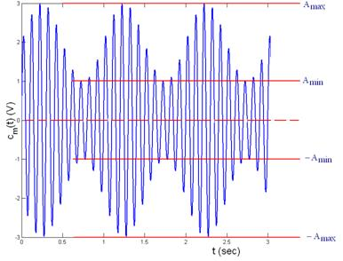

Figure-3: Envelope variation of amplitude modulated carrier

Therefore we can write,



Given the sinusoidally modulated wave as shown in Figure 3, the modulation index m can be computed by measuring Amax and Amin

The power in the carrier wave component is given by



The power in each of the side frequencies is given by

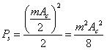

The total power P T is given by



With m=1, only 25% of the carrier power is present at the side frequencies.

       The merit of amplitude modulated carrier is the ease with the baseband signal can be recovered. The process of recovery of modulating signal is called demodulation. The demodulation of DSB AM signal can be done either by using an envelope detector or by passing the amplitude modulated signal through a non-linear device. In this experiment, we shall consider demodulation using envelope detector.

**CHAPTER 2**

**LITERATURE SURVEY**

**2.1 GENERAL**

The literature that have been presented on the topic of VIRTUAL LABS are studied and presented under different topics and different domains and different experiments but with a common source known as VIRTUAL LABS .The inferences that we understood from a few of those literatures are mentioned below.

**2.2 REVIEW OF LITERATURE**

1. **Shyam Diwakar, Krishnashree Achuthan and Prema Nedungadi** have published a paper on Biotechnology virtual labs- Integrating wet-lab techniques and theoretical learning for enhanced learning at universities. Establishing virtual labs requires both domain knowledge and virtualizing skills via programming, animation and device-based feedback. Challenges in the biotechnology sector in setting up a laboratory that integrates both the feel and phenomenon includes the medley of multiple techniques. The major challenge in setting up an effective knowledge dissemination for laboratory courses was not only the scientific approach of biotechnology, but included the virtualization aspects such as usage/design scalability, deliverability efficiency, network connectivity issues, security and speed of adaptability to incorporate and update changes into existing experiments. This paper also discusses an issue-specific case-study of a functional virtual lab in biotechnology and its many issues and challenges.

2**. Jai P. Agrawal** and **Yakov E Cherner** have published a paper on “A Classroom/Distance Learning Engineering Course on Wireless Networking with Virtual Lab”. Paper presents the design of an engineering course on “Wireless Networking” in a traditional classroom /distance learning format. The paper will also show that how classroom learning can be enhanced by making available to learners the classroom lecture in audio /video/pdf format from anywhere and at all times on demand.

3. **Lavanya Rajendran, Ramachandran Veilumuthu** and Divya**. J** paper on study on the effectiveness of virtual lab in E-learning. The research aims to identify the effectiveness of virtual lab in E-learning suite. The study aims to analyse the increase in learning skills and the understanding level of concepts by implementing virtual lab among school students in Chennai. The study also focuses on identifying whether the virtual lab helps the students to increase the self-paced learning. The study suggests that the virtual labs have to be adopted in schools for making their students think out of the box.

4**. S. Diwakar, D. Kumar, R. Radhamani, H. Sasidharakurup, N. Nizar, K. Achuthan, P. Nedungadi, R. Raman,** and **B. Nair** paper on Complementing Education via Virtual Labs: Implementation and Deployment of Remote Laboratories and Usage Analysis in South Indian Villages. Enabled virtual and remote labs have become a platform augmenting user engagement in blended education scenarios enhancing University education in rural India. A novel trend is the use of remote laboratories as learning and teaching tools in classrooms and elsewhere. This paper reports case studies based on our deployment of 20 web-based virtual labs with more than 170+ online experiments in Biotechnology and Biomedical engineering discipline with content for undergraduate and postgraduate education.

**CHAPTER 3**

**METHODOLOGY**

**3.1 GENERAL**

The user enters the experiment page and will be able to view the Aim, Apparatus Required, Theory, Procedure, Pre-test, Experiment Simulation, Post-test and Result sections.

The student is expected to go through the sections in the provided order in order to get a proper understanding of the experiment.

The aim gives a proper definition of the experiment which needs to be carried out. The apparatus required gives the list of devices used to perform the experiment physically. The Pre-test gets the user aware and in touch with the field of experiment.

The simulations tab consists of components which can control the parameters involved in the experiment similar to its real life equivalent.

The graphs or waveforms involved in the experiment will be provided in a canvas which can be varied according to the change in parameters.

The waveforms will be displayed in an easy-to-understand manner with contrasting colours and fluid motion.

The parameters can be changed using sliders which indicate the values along with their units.

The formulas to be used will be displayed along with the results and observation towards the end of simulation window.

Each important step in the simulation will be prefaced with a quiz question which will help the user understand the steps and concept behind each step more effectively.

After the simulation is performed and the waveforms are studied by the user, they proceed to the post-test section which contains questions based on the experiment they performed.

This will ensure a clear understanding of the concept with an easier way to visualize these waveforms involved.

**3.2 FREQUENCY MODULATION**

Frequency modulation (FM) is a type of modulation where the frequency of the carrier is varied in accordance with the modulating signal. The amplitude of the carrier remains constant.

The information bearing signal (the modulating signal) changes the instantaneous frequency of the carrier. Since the amplitude is kept constant, FM modulation is a low noise process and provides a high quality modulation technique which is used for music and speech in hi-fidelity broadcasts.

From the definition of frequency deviation, an equation can be written for the signal frequency of an FM wave as a function of time:

*V(t) = A sin(*2π*(fc +m(sin*2π*fmt))t+ Θ)*

The constant is the modulation index for FM. It is defined as follows:

*m=*Δf*/*f*m*

**3.2.1 PROCEDURE FOR FM**

1. After reading the theory and attending the pre-test, click the "Simulation" tab.
2. The interactive simulator will be displayed.

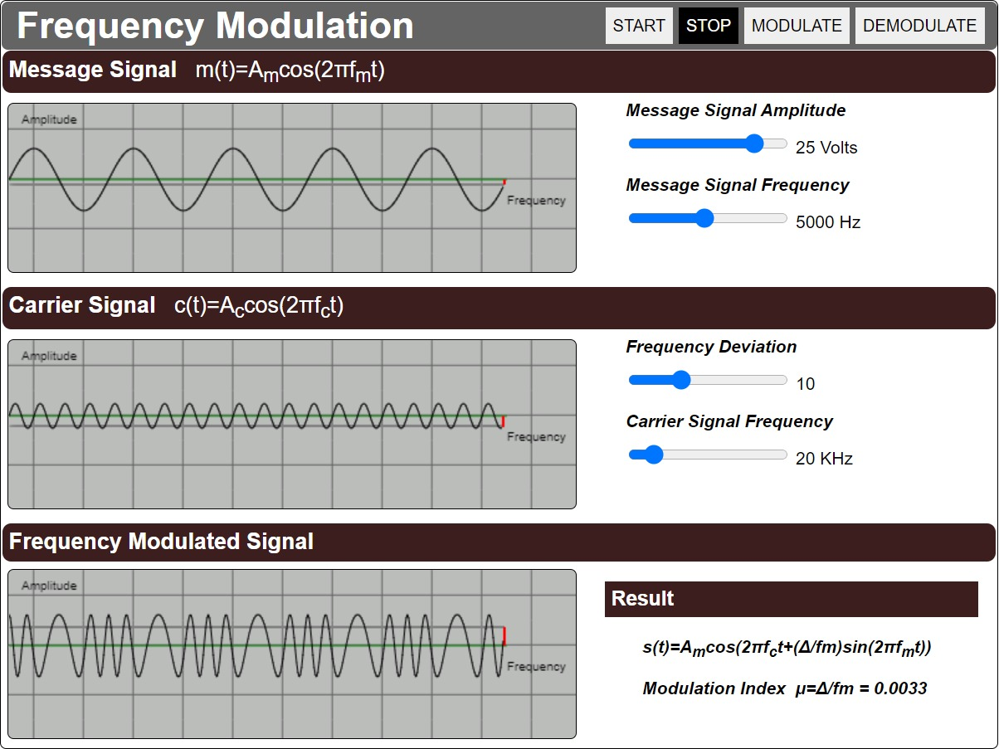

1. Set the Message Signal Amplitude and Frequency.

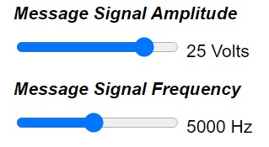

1. Set the Carrier Signal Frequency and Frequency deviation.

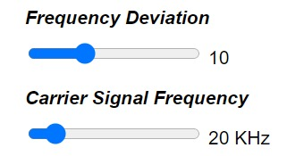



1. Click on "Modulate" button. This will Show the Modulated Message Signal Simulation Screen.
2. Click on "Start" button. This will start the Simulation.
3. Click on "Demodulate" button. This will Show the Demodulated Message Signal.
4. Click on "Stop" button to view the graph in a Static state.
5. In the Results Section you can view the modulation Index and type of modulation (with respect to modulation index)

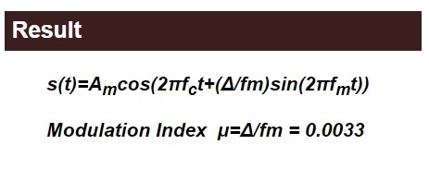

1. The post test questions will be displayed, attempt the questions to check the understanding about the experiment.
2. Note the conclusions from the experiment performed.

**3.2.2 FM FLOWCHART**

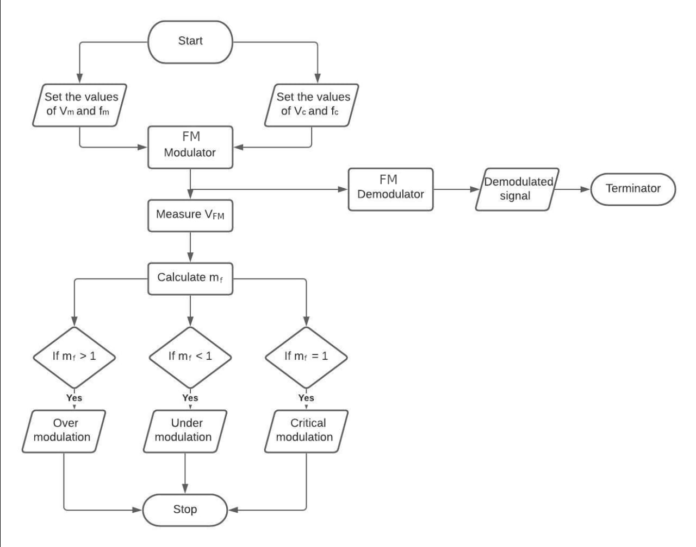

**3.3 AMPLITUDE SHIFT KEYING**

Amplitude Shift Keying (ASK) is the digital modulation technique. In amplitude shift keying, the amplitude of the carrier signal is varied to create signal elements. Both frequency and phase remain constant while the amplitude changes.

In ASK, the amplitude of the carrier assumes one of the two amplitudes dependent on the logic states of the input bit stream. This modulated signal can be expressed as:

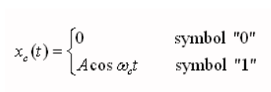

**3.3.1 PROCEDURE FOR ASK**

1. After reading the theory and attending the pretest, click the "Simulation" tab.
2. The interactive simulator will be displayed.

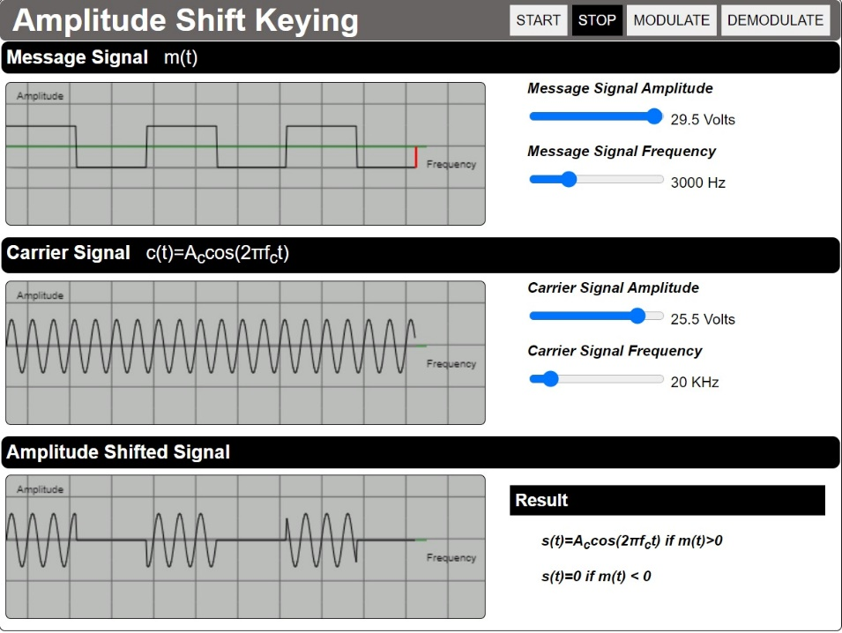

1. Set the Message Signal Amplitude and Frequency.

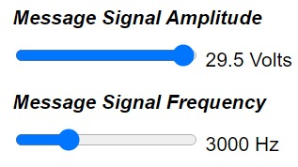

1. Set the Carrier Signal Amplitude and Frequency.

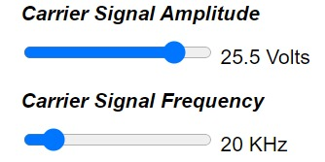



1. Click on "Modulate" button. This will Show the Modulated Message Signal Simulation Screen.
2. Click on "Start" button. This will start the Simulation.
3. Click on "Demodulate" button. This will Show the Demodulated Message Signal.
4. Click on "Stop" button to view the graph in a Static state
5. In the Results Section you can view the modulation Index and type of modulation (with respect to modulation index).

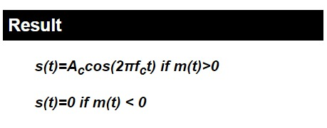

1. The post-test questions will be displayed, attempt the questions to check the understanding about the experiment.
2. Note the conclusions from the experiment performed.

**3.3.2 ASK FLOWCHART**

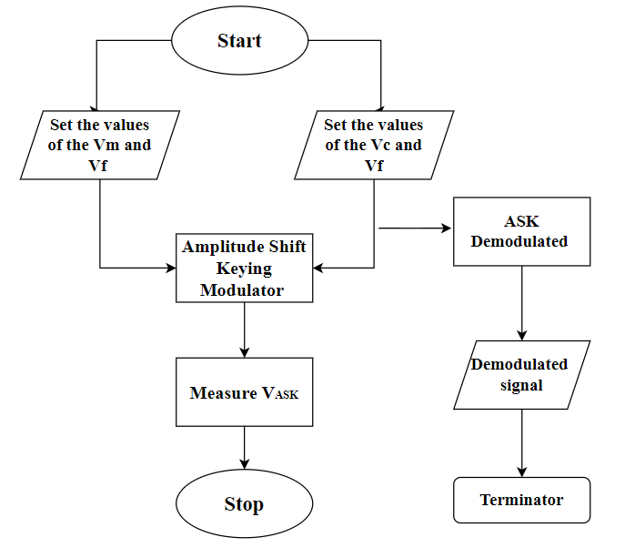

**3.4 FREQUENCY SHIFT KEYING**

In frequency-shift keying, the signals transmitted for marks (binary ones) and spaces (binary zeros) are respectively.

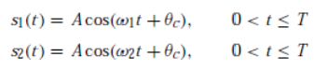

**3.4.1 PROCEDURE FOR FSK**

1. After reading the theory and attending the pre-test, click the "Simulation" tab
2. The interactive simulator will be displayed

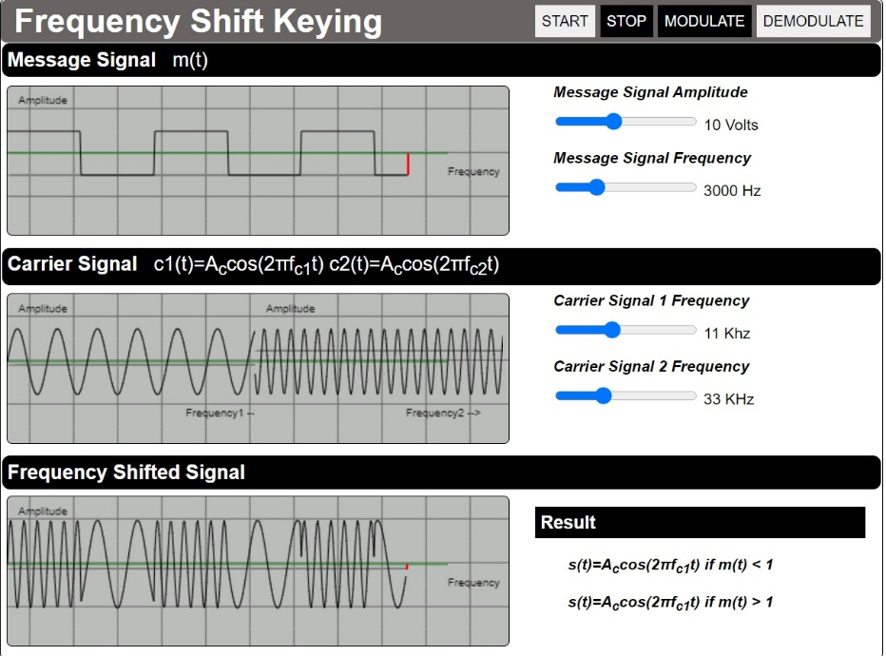

1. Set the Message Signal Amplitude and Frequency.

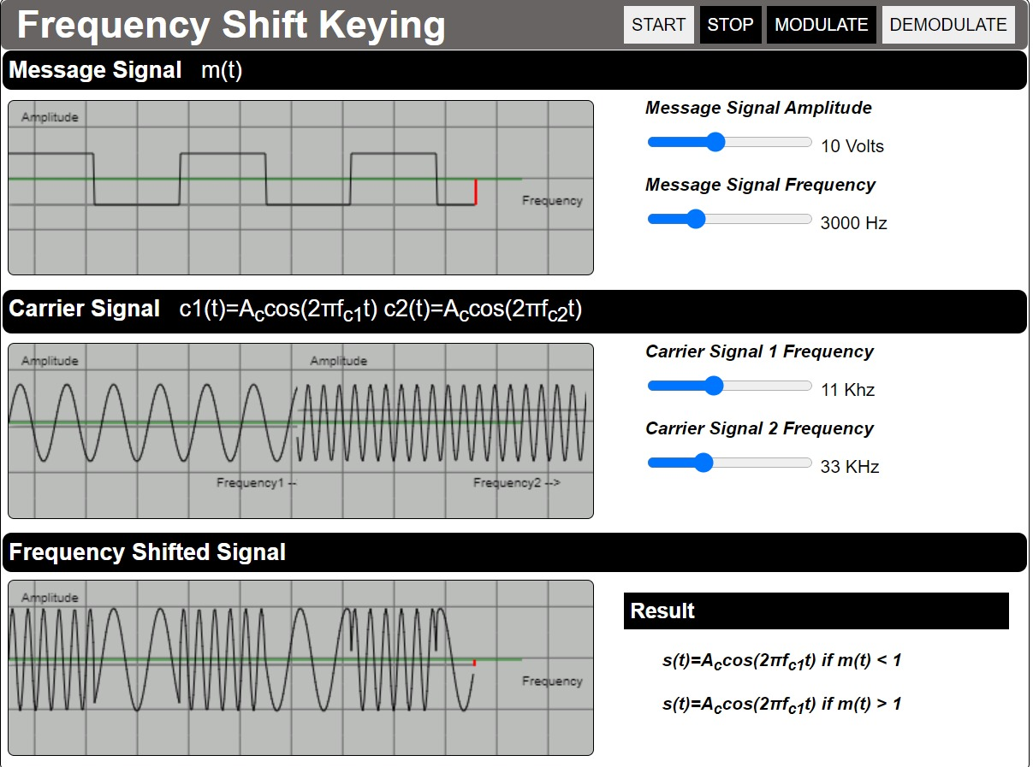

1. Set the Carrier Signal Frequency1 and Frequency2.





1. Click on "Modulate" button. This will Show the Modulated Message Signal Simulation Screen.
2. Click on "Start" button. This will start the Simulation.
3. Click on "Demodulate" button. This will Show the Demodulated Message Signal.
4. Click on "Stop" button to view the graph in a Static state
5. In the Results Section you can view the modulation Index and type of modulation (with respect to modulation index).



1. The post-test questions will be displayed, attempt the questions to check the understanding about the experiment.

Note the conclusions from the experiment performed

**3.4.2 FSK FLOWCHART**

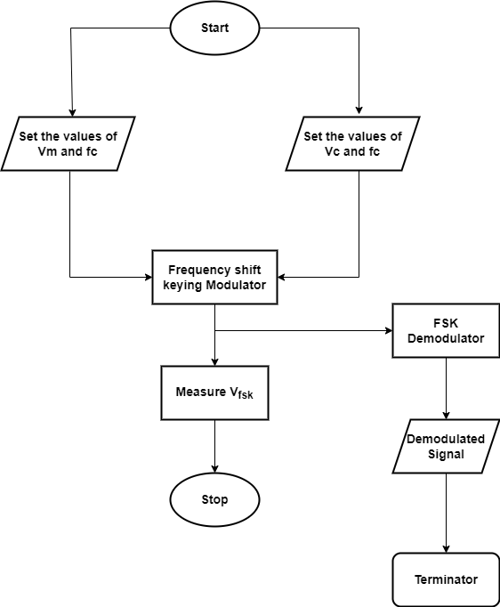

**3.5. PULSE CODE MODULATION**

It is a standard form of digital audio in computers , compact discs , digital telephony and other digital audio application . In a PCM stream , the amplitude of the analog signal is sampled regularly at uniform intervals , and each sample is quantised to the nearest value while within a range of digital steps

**PROCEDURE FOR PCM**

After reading the theory and attending the pre-test, click the "Simulation" tab

1. The interactive simulator will be displayed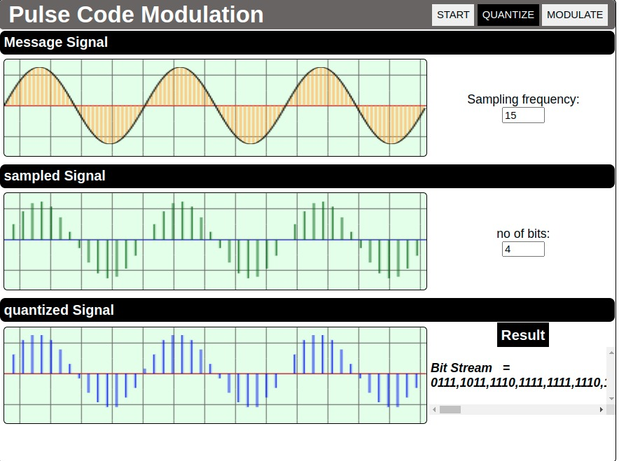
2. Set the sampling frequency.



1. Set the no of bits





1. Click on "Modulate" button. This will Show the Modulated Message Signal Simulation Screen.
2. Click on "Start" button. This will start the Simulation.
3. Click on "Demodulate" button. This will Show the Demodulated Message Signal.
4. Click on "Stop" button to view the graph in a Static state
5. In the Results Section you can view the modulation Index and type of modulation (with respect to modulation index).



1. The post-test questions will be displayed, attempt the questions to check the understanding about the experiment.

Note the conclusions from the experiment performed

**3.6. AMPLITUDE MODULATION**

**3.2.1 PROCEDURE FOR FM**

1. After reading the theory and attending the pre-test, click the "Simulation" tab.
2. The interactive simulator will be displayed.

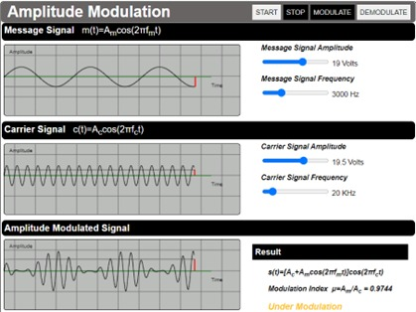

1. Set the Message Signal Amplitude and Frequency.



1. Set the Carrier Signal Frequency and Frequency deviation.





1. Click on "Modulate" button. This will Show the Modulated Message Signal Simulation Screen.
2. Click on "Start" button. This will start the Simulation.
3. Click on "Demodulate" button. This will Show the Demodulated Message Signal.
4. Click on "Stop" button to view the graph in a Static state.
5. In the Results Section you can view the modulation Index and type of modulation (with respect to modulation index)



1. The post test questions will be displayed, attempt the questions to check the understanding about the experiment.
2. Note the conclusions from the experiment performed.

**4. SYSTEM ARCHITECTURE**

**4.1 GENERAL**

This project aims to create a virtual simulator using simple and widely used technology like javascript, HTML and CSS. Usage of additional libraries and packages are restricted in order to maintain a compact file size and reduce the complexity for future development processes.

The technology stack was chosen such that the simulator will be compatible with most modern web browsers out of the box, without the requirement of installation of any additional tools

**4.2 TECHNOLOGY STACK:**

1. **HTML** **(Hypertext Markup Language)**: It is the most basic building block of the Web page. It defines the structure and meaning of web content. HTML consists of a series of [elements](https://developer.mozilla.org/en-US/docs/Glossary/Element), which is used to enclose, or wrap, different parts of the content to make it appear a certain way, or act a certain way. For example, the enclosing [tags](https://developer.mozilla.org/en-US/docs/Glossary/Tag) can make a word or image hyperlink to somewhere else, can italicize words, can make the font bigger or smaller, etc.

2. **CSS (Cascading Style Sheets (CSS):** It is a [stylesheet](https://developer.mozilla.org/en-US/docs/Web/API/StyleSheet) language used to describe the presentation of a document written in [HTML](https://developer.mozilla.org/en-US/docs/Web/HTML) or [XML](https://developer.mozilla.org/en-US/docs/Web/XML/XML_introduction). CSS describes how elements should be rendered on screen, on paper, in speech, or on other media. CSS is among the core languages of the open web and is standardized across Web browsers according to [W3C specifications](https://www.w3.org/Style/CSS/#specs).

3. **Javascript:** It is a lightweight, interpreted, or [just-in-time](https://en.wikipedia.org/wiki/Just-in-time_compilation) compiled programming language with [first-class functions](https://developer.mozilla.org/en-US/docs/Glossary/First-class_Function). While it is most well-known as the scripting language for Web pages, [many non-browser environments](https://en.wikipedia.org/wiki/JavaScript#Other_usage) also use it. JavaScript is a [prototype-based](https://developer.mozilla.org/en-US/docs/Glossary/Prototype-based_programming), multi-paradigm, single-threaded, dynamic language, supporting object-oriented, imperative, and declarative styles. The standards for JavaScript are the [ECMAScript Language Specification](https://tc39.es/ecma262/).

**4.3 STRUCTURE OF THE PROGRAM:**

The project is structured in such a way that the HTML file acts as the core skeletal structure which can access every other script, images and style-sheets required for the simulator.

Every image, CSS and javascript files are placed in their respective folders. This makes it easier to call these files from within the HTML.

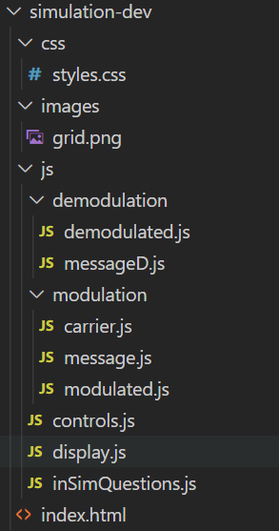

The javascript codes are also divided into modules depending on the task they are assigned to carry out.

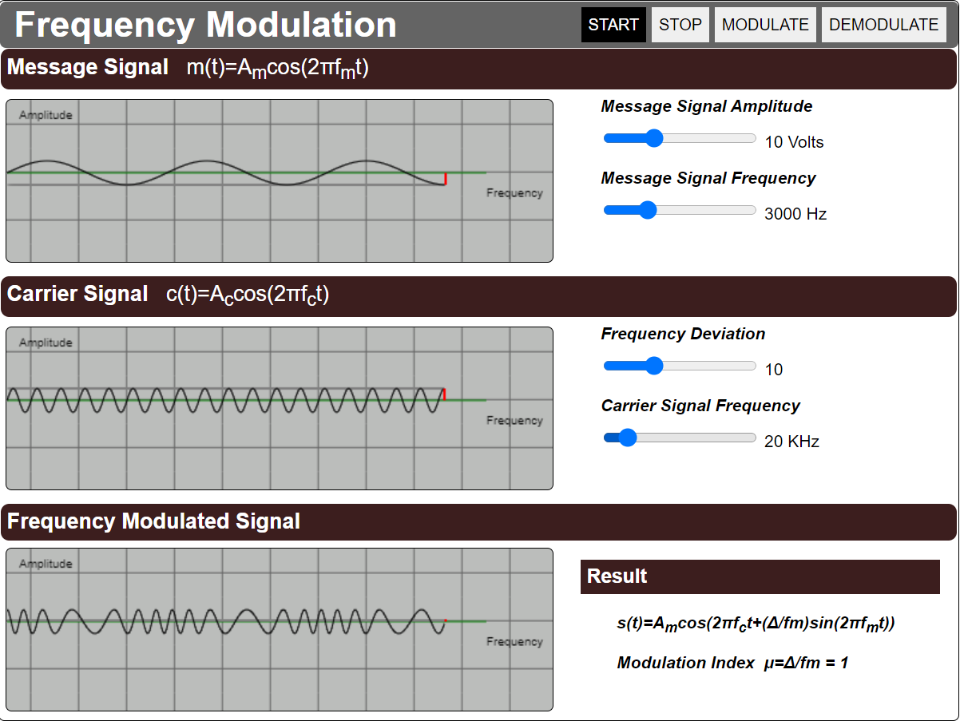

**CONTROL.JS**

**DISPLAY.JS**

**DISPLAY.JS**

**DISPLAY.JS**

**MODULATED.JS**

**CARRIER.JS**

**MESSAGE.JS**

The **display.js** takes care of the input values from the sliders and relays these values to the functions which calculate the values for parameters like modulation index.

The **control.js** takes care of the functioning of the buttons like start, stop, modulate and demodulate.

The modulation folder contains scripts responsible for the waveforms corresponding to the message, carrier and modulated signals.

Each waveform is drawn using *canvas,* which is an html tool used to generate graphical illustrations using javascript.

The **message.js** generates a message signal based on the input voltage and frequency retrieved from display.js. It consists of two functions, one to calculate the value of message signal according to their respective formulas (either a sine wave or a square wave), the other function plots the wave form on the canvas while providing an animation for its path of propagation.

The **carrier.js** generates the carrier signals based on the input of the voltage and frequency retrieved from display.js. It consists of two functions, one to calculate the value of a high frequency carrier signal with appropriate max voltage using appropriate formulas, the other function plots the waveform of this signal on the canvas while providing an animation of its propagation path.

The **modulated.js** file generates the modulated signal based on the simulated experiment. It computes the value of the modulated signal using the respective formulas. The modulated signal is plotted on the canvass based on the calculated signal with respect to time.

**CONTROL.JS**

**DEMODULATED.JS**

**MESSAGED.JS**

**DISPLAY.JS**

**DISPLAY.JS**

**DISPLAY.JS**

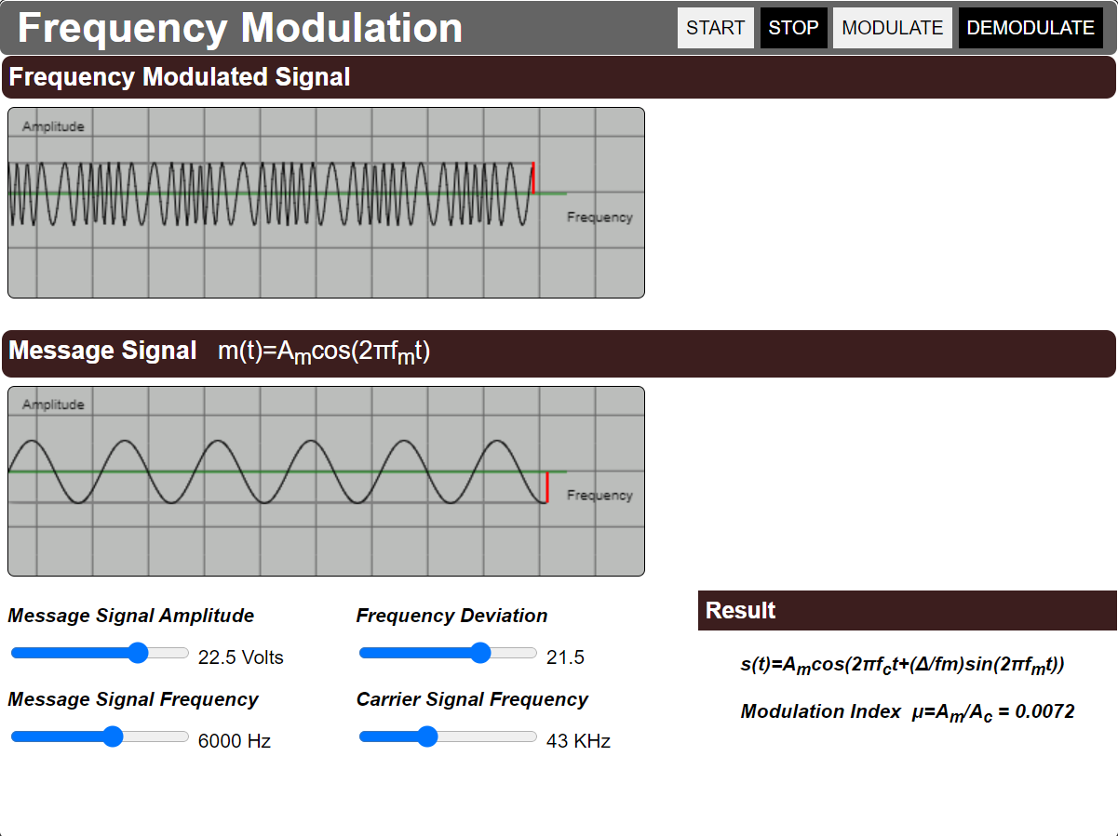

When the “demodulate” button is clicked, the demodulation screen will be displayed. This function is carried out by the **control.js** file.

In the demodulation screen the values from the sliders for each parameter is controlled and displayed through the **display.js file**. It also takes care of showing the result which involves a dynamic value like modulation index when necessary.

The **demodulated.js** file performs the same function as the modulated.js in the demodulation screen. It takes in the parameters from the display.js file and computes the value of modulated signal and plots the waveform accordingly.

The **messageD.js** file performs the demodulation of the modulated signal and produces back the message signal.

Additionally, the **inSimQuestions.js** file prompts multiple choice questions when each control button is pressed. This is to ensure the understanding level of the concept by the user.

**4.4 FORMULAE USED:**

Each simulation mainly varies in the equations each waveform uses to plot themselves.

**4.4.1 FREQUENCY MODULATION:**

In frequency modulation both the carrier and message signals are sinusoidal waves. Their equations are:

Message signal, **m(t)=Amcos(2πfmt)**

Carrier Signal, **c(t)= Accos(2πfct)**

Here, Am is the maximum amplitude of message signal,

Ac is the maximum amplitude of carrier signal,

Fc is the frequency of the carrier and

Fm is the frequency of the message signal.

The frequency modulated signal is given by,

**s(t)=Amcos(2πfct+(Δ/fm)sin(2πfmt))**

Here, Am is the maximum amplitude of message signal,

Fc is the frequency of the carrier,

Fm is the frequency of the message signal,

**Δ** is the frequency deviation

Formula used for calculation modulation index to decide the degree of modulation is given by:

Where,

is the modulation index,

is the frequency of message signal

is the frequency deviation,

**4.4.2 AMPLITUDE SHIFT KEYING**

In ASK the message signal is a digital binary data and the carrier signal is a high frequency carrier signal.

The ASK modulated signal can be given by

Where,

A(t) is the ASK signal

is the maximum amplitude of carrier signal,

is the frequency of carrier signal,

**4.4.3 FREQUENCY SHIFT KEYING**

In FSK the message signal is a digital binary data and the carrier signals are two high frequency signals where one frequency is always higher than the other frequency.

Equation to represent frequency shift keying can be given by,

Where,

F(t) is the FSK signal

is the maximum amplitude of carrier signals,

is the high frequency of carrier signal,

is the low frequency of carrier signal,

**4.4.4 PULSE CODE MODULATION**

Equation to represent step size of the quantized signal is given by,

Where, L=2n where n is the number of bits

*Vmax,* is the maximum amplitude of message signal

*Vmin,* is the minimum amplitude of the message signal

Sampling frequency,

**4.4.5 AMPLITUDE MODULATION**

In frequency modulation both the carrier and message signals are sinusoidal waves. Their equations are:

Message signal, **m(t)=Amcos(2πfmt)**

Carrier Signal, **c(t)= Accos(2πfct)**

Here, Am is the maximum amplitude of message signal,

Ac is the maximum amplitude of carrier signal,

Fc is the frequency of the carrier and

Fm is the frequency of the message signal

The frequency modulated signal is given by,

**s(t)=[Ac+Amcos(2πfmt)]cos(2πfct)**

Here, Am is the maximum amplitude of message signal,

Fc is the frequency of the carrier,

Fm is the frequency of the message signal,

**Δ** is the frequency deviation

Formula used for calculation modulation index to decide the degree of modulation is given by:

***μ=Am/Ac***

Where,

*μ* is the modulation index,

is the Amplitude of message signal

is the Amplitude of carrier Signal

**CONCLUSION**

It is clear that the resultant waveform obtained is in accordance with the theoretical waveforms of the basic digital modulation techniques. Thus, we are successful in attaining our objective in this paper.

**ASK:** Strength of carrier signal is varied to represent binary 1 or 0. Both frequency& phase remains constant while amplitude changes, commonly, one of the amplitudes is zero. ASK is used to transmit digital data over optical fibre.

**FSK:** Frequency of carrier signal is varied to represent binary 1 or 0. Peak amplitude & peak phase remains constant during each bit interval. FSK is less susceptible to error than ASK receiver looks for specific frequency changes over a number of intervals. So, voltage (noise) spikes can be ignored. FSK is used over voice lines, in high frequency radio transmission etc

**FM:** As observed in FM modulation results, the spectrum is having number of upper side band and lower side bands along with same equation produced for AM. The modulation of any carrier creates sidebands and their bandwidth and amplitude are straightforward. The Frequency modulation sidebands are dependent in both level of the deviation and frequency modulation. Therefore, from what it was obtained from FM spectrum of FM front panel in results, the modulation spectrum included the carrier plus an infinite number sideband.

**PCM:** A better understanding of Pulse Code Modulation by further probing into sampling and quantization. You verified the introduction of aliasing by sampling a signal at a rate lower than that dictated by the sampling theorem. You also verified the consequence of reducing the quantization levels by limiting the number of bits utilized to represent a signal. The concepts of sampling and quantization are fundamental to a multitude of areas in engineering.

**REFERENCE**

1. Shyam Diwakar, Krishnashree Achuthan and Prema Nedungadi. “Biotechnology virtual labs- Integrating wet-lab techniques and theoretical learning for enhanced learning at universities.”
2. 2. Jai P. Agrawal and Yakov E Cherner. “A Classroom/Distance Learning Engineering Course on Wireless Networking with Virtual Lab”.
3. Lavanya Rajendran, Ramachandran Veilumuthu and Divya. J. “study on the effectiveness of virtual lab in E-learning”
4. S. Diwakar, D. Kumar, R. Radhamani, H. Sasidharakurup, N. Nizar, K. Achuthan, P. Nedungadi, R. Raman, and B. Nair paper on Complementing Education via Virtual Labs: Implementation and Deployment of Remote Laboratories and Usage Analysis in South Indian Villages